MINUTES OF THE OSALL AGM

Held virtually

Thursday, 5 August 2021

- WELCOME

Karabo Moleya welcomed everyone to the virtual AGM. She introduced the guest speaker, Terry Harrison, who addressed members on e-Discovery in South Africa.
A question and answer session followed the presentation. Lydia Craemer asked if Terry's book covers POPIA, as it was published before parts of the act came into force. Terry affirmed that it did, and that there is a chapter on Data Protection. Karabo thanked Terry for his presentation.

This was followed by a mindfulness session presented by Sanet, which helped members to relax.

APOLOGIES
Fanus Olivier
Meryl Federl
Annalise de Wet
Sharon Pather-Nagy

- MINUTES

The minutes of the previous meeting were approved by Hesma van Tonder after Danielle Botha read them out. Tanya Hubbard, Charmaine Bertram and Ruth Ward seconded.

- MATTERS ARISING
Karabo Moleya mentioned that Carol Coetzee was retiring at the end of August. Carol was thanked by everyone for her many years of dedication to OSALL and its members.

- REPORTS
4.1 OSALL Chair

Karabo Moleya read the Chair's report.

2020-2021 CHAIRPERSON REPORT By Karabo Moleya

OSALL is a non-profit organization which is aimed at supporting everyone in the law library environment. We find ourselves in uncertain times, overwhelmed and unsure of what’s to come. The current pandemic has taught me is to live each day as if it was my last and make every moment count. As we reach the end of the term, I would like to thank our sponsors who have helped us in the important work of bringing our members together since lockdown was imposed.

LexisNexis, Sabinet, Juta and Academic Market Services – we are forever grateful for your support. Special word of appreciation to Michael Botha for keeping our website safe from cybercriminals. I would like to convey my gratitude to Helen Demetriou who unfortunately had to vacate her role before the end of her term, and to Danielle Botha for stepping in and continuing to make sure that we deliver as mandated.

To all our members who have retired – we wish you a happy and enjoyable retirement especially to Carol Coetzee from LexisNexis who has become a special friend to many of us and to Osall. To the current committee, I appreciate you and thank you for believing in me and for availing yourselves to serve and most importantly for sticking with me through it all. Together we made it!

2020/2021 Executive Committee

Chairperson: Karabo Moleya

Vice Chair: Amanda Franken

Secretary and Website: Danielle Botha

Treasurer: Hesma Van Tonder

PR: Yani Gaba

Membership: Audrey Lenoge

Additional members: Patricia Makhoba

Activities: Not a lot has happened in the previous year, but we were fortunate to have our first networking session for 2021 which was hosted by Sabinet. This was followed by an informative virtual cloud computing online workshop by Randal Pienaar.

I am happy to report that OSALL made submissions to the Copyright Amendment Bill 13 of 2017 which is currently in the public hearing stage in Parliament. Conferences: • SAOIM conference - the planning for the conference has started and new dates will be communicated in due course.

BIALL 2021 and AALL 2021 – I am happy to report that OSALL was once again represented at the 2 conferences. Lastly, nomination forms has been sent out and we received very poor response from our members, It is the responsibility of each one of us to make sure that this organisation remains a successful platform for everyone in the law library environment and would therefore like to request big institutions to consider being represented in the committee.

4.2 Treasurer

Hesma van Tonder read the financials.

OSALL TREASURER’S REPORT 2020/2021

OSALL Books were audited by Vincent Laubscher and Associates.

OSALL has total assets to thebalance of R126,595.00
Notice account: R72,380.97
Current account: R26,724.91 (R20 000 was transferred to the Notice account)
Accounts receivable: R9,924.20

INCOME: R 24,913.71
Advertising Income: R 3,965.22
Listserv: R 3,365.22
Newsletter: R 600.00
Interest capitalised (Notice account): R 1,407.19
Membership Fees: R 16,941.30
Individual: R 5,251.30 (24members)
Institutional/Corporate: R 10,840.00 (16 institutions)
Retired: R 140.00 (2 members)
Sponsorships: R 2,000.00 (for best newsletter article)

EXPENSES: R 51,492.44
Accounting Fees: R 5,958.70
Bank Charges: R 1,542.50
STD Bank’s Monthly Management fee: R 1,034.50
STD Bank’s Service fee: R 508.00
Functions: R 14,108.00
Gifts (AGMs,speakers, etc.): R 29,298.24
Computer expenses: R 585.00

4.3 Newsletter Editor

Tanya Hubbard read the newsletter report.

Newsletter Report 2020-2021

To quote Charles Dickens “It was the best of times, it was the worst of times…” which about sums up my feelings on 2020/2021.

With the pandemic still being a real threat to us all; the committee decided to find out how you the members
would feel about reducing the number of newsletters and quite a number of you responded to our survey monkey and indicated a willingness to accept the proposal. Going forward the newsletter will be published three times per annum.

This was also the reason why only one issue was published during this report back period being the May
2021 edition. There may have only been one issue but I still think it was a bumper one.
Lydia Craemer wrote a very moving tribute to the Jagger Library at UCT, “The day hell consumed a library in the shadows of Devil’s Peak”. I don’t think any of us will ever forget the images we saw as the fire consumed so much of Cape Town’s heritage, but once again South Africans proved we can overcome anything and the overwhelming support from the public in assisting the mop up efforts was truly humbling.
Gail Dendy submitted an insightful article on working from home titled “Future Perfect” and our very own
Chairperson Karabo Moleya wrote about a panel discussion she had been a part of where she defended
her argument about how law libraries are not ready to shelve books but are embracing the 4th industrial
revolution at a pace suitable for librarians and clients, titled “Should books be shelved? The role of libraries in the internet age”. A topic I’m sure we are all very familiar with.
The issue finished off with Izette Knoetze-le Roux’s contribution “A reflection on the progress of bills passed
by the democratic parliament since 1994”. A friendly reminder that all past newsletters can be accessed on the OSALL website.

Finally, seven years ago I stood in front of many of you and confessed a childhood dream of becoming a magazine editor and waxed lyrical about how excited I was to be OSALL’s newsletter editor. I’m still excited every time I send out an issue but I do believe it is time for someone new to take over; so with that in mind I am stepping down as editor. I want to thank all of you who have helped make these years so special and who have contributed such amazingmaterial.

4.4 Listserv Administrator

Danielle Botha read the Listserv report on behalf of Joyce Khakhu.

Listserv report 2020/2021

I am pleased to report that the OSALL listserv mail list is working properly. In June 2021 only a few problems like not receiving and unable to send emails were reported. The repercussion noted with the problem emails was the use of old email addresses. This was attended to and sorted out. Some emails continue to bounce but they are released as soon as they are spotted.
In response to the POPI Act compliance email sent out to all members in June 2021, we had 3 members who
unsubscribed from the list in July, 2 new members subscribed to the list, 2 old email addresses were modified. Our current listserv membership this year is 348. The listserv looks good and currently no bouncing mails are waiting for distribution. I can confidently report there are no technical glitches.

4.5 Website Administrator

Danielle Botha read the website report.

Website Administrator's Report Aug 2020 – Jul 2021

OSALL, like the rest of the world, was disrupted by that pesky pandemic called COVID-19, which put an end to any physical OSALL meetings, from end March 2020 to date.
The OSALL website was unfortunately hacked on 29 April 2021. The site went offline as garbage information was inserted into the headers, however neither the database nor the backend was affected. Michael Botha had to pull in a backup to get the site up and running again.
Our total number of visitors grew to 242,926 from 202,342 the previous year.
Site Statistics as at 28 July 2021.
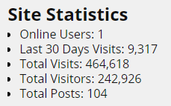
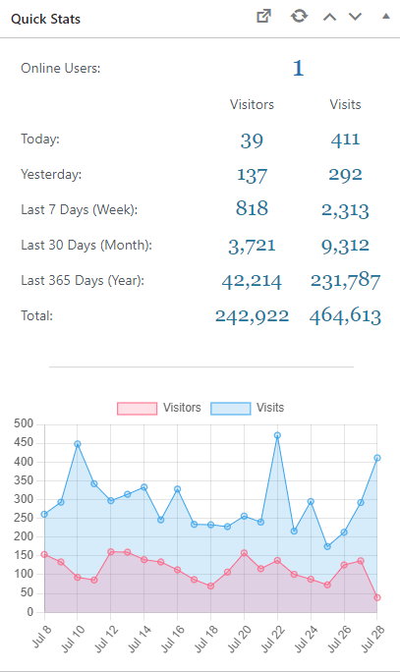
We had more visitors from the United States than from South Africa. Please see the top ten countries visitor count for the past year below.

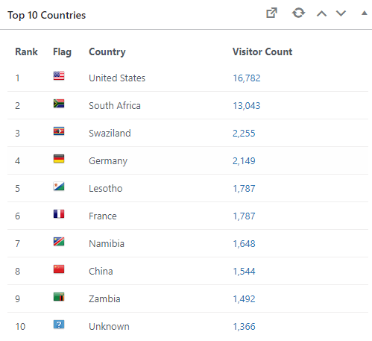
We would like to thank our loyal suppliers, LexisNexis, Sabinet and Juta for their generous support throughout this term. We also thank Michael Botha for donating his valuable time in support.

- LUCKY DRAWS
LexisNexis gave two lucky winners a copy each of A Guide to eDiscovery in South Africa, authored by Terry Harrison and Advocate Ismail Hussain SC. Carol Coetzee named the lucky draw winners:

• Thembeka Sotshononda – Legal Information Specialist at ENSafrica;
• Kathy Knight – Librarian at Webber Wentzel.

